TEFL – Teaching English as a Foreign Language / Fachdidaktik Englisch
Institute of Anglistik/Amerikanistik
University of Bamberg
[title of seminar]
[module (Modulzuordnung) and ECTS points]
[name of the university lecturer (with academic titles)]
Seminar paper / Portfolio / Final thesis (BA, MA, or Zulassungsarbeit)
[Topic]
Supervisor | [xxx]
Author | [Name Surname]
Matriculation number | [xxx]
E-mail | [xxx@stud.uni-bamberg.de]
Course of study | [xxx]  [x. term of studying in this field/ x. term at university]
Date of submission | [MM/DD/YYYY]

[If you wrote the paper in pairs, please use this title page]
TEFL – Teaching English as a Foreign Language / Fachdidaktik Englisch
Institute of Anglistik/Amerikanistik
University of Bamberg
[title of seminar]
[module (Modulzuordnung) and ECTS points]
[name of the university lecturer (with academic titles)]
Seminar paper / Portfolio / Final thesis (BA, MA, or Zulassungsarbeit)
[Topic]
Supervisor | [xxx] | [xxx]
Authors | [Name Surname] | [Name Surname]
Matriculation number | [xxx] | [xxx]
E-mail | [xxx@stud.uni-bamberg.de] | [xxx@stud.uni-bamberg.de]
Course of study | [xxx]  [x. term of studying in this field/ x. term at university] | [xxx]  [x. term of studying in this field/ x. term at university]
Date of submission | [MM/DD/YYYY] | [MM/DD/YYYY]

Table of contents
List of abbreviations 1
List of figures 2
List of tables 3
1. Introduction 4
2. Main section 4
2.1. [Heading of the subchapter] 4
2.2. [Heading of the subchapter] 4
2.2.1. [Paragraph of a subchapter] 4
2.2.2. [Paragraph of a subchapter] 5
2.3. [Heading of the subchapter] 5
2.3.1. [Paragraph of a subchapter] 5
2.3.2. [Paragraph of a subchapter] 5
3. Conclusion 6
References 7
Appendices 9
Declaration of Academic Integrity 10
Personal Report on the use of Artificial Intelligence (AI) tools 11

List of abbreviations
EFL | English as a foreign language
SLA | Second language acquisition

List of figures
Figure 1: Terrible troll: Sample of colouring and writing
Figure 2: Word-forks

List of tables
Table 1: Top three picturebooks used by teachers in three different studies

Introduction
[This is an example text to show how paragraphs should look like. A new paragraph is indicated by starting a new line.]
[So, this should look like this. …]

Main section
  - [Heading of the subchapter]
[Text body]
  - [Heading of the subchapter]
[Text body]
    - [Paragraph of a subchapter]
Figure 1 shows … / As illustrated in Figure 1, …
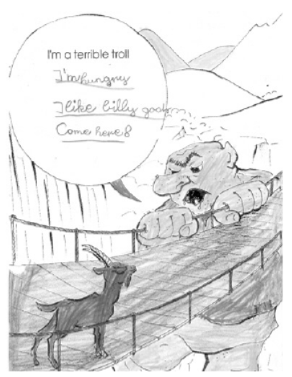
Figure 1: Terrible troll: Sample of colouring and writing (Bland 2015: 210)
[Text body]
    - [Paragraph of a subchapter]
[Text body]
  - [Heading of the subchapter]
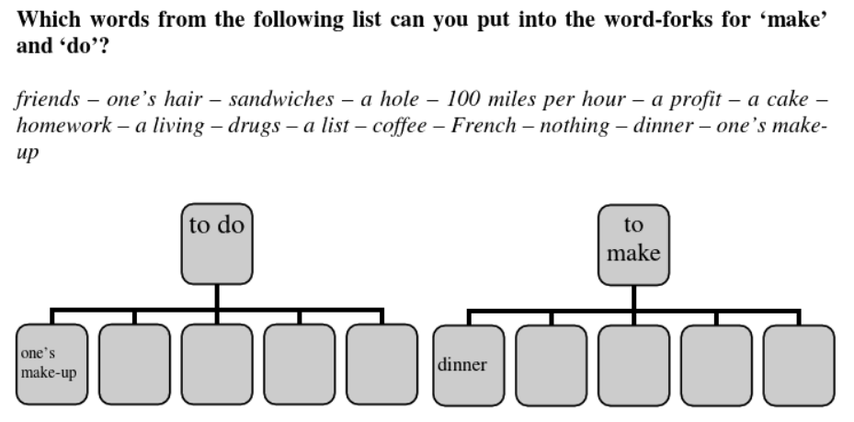
[Text body]
Figure 2: Word-forks (Eisenmann & Summer 2017: 115)
[Text body]
    - [Paragraph of a subchapter]
[Text body]
    - [Paragraph of a subchapter]
[Text body]
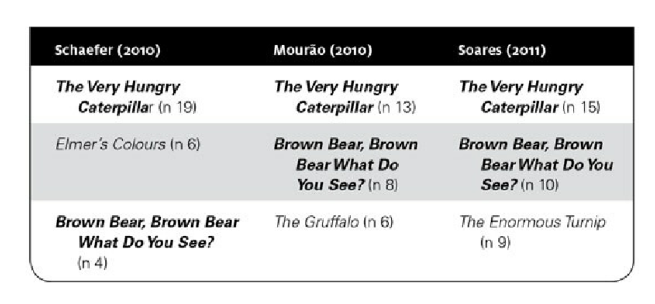Table 1: Top three picturebooks used by teachers in three different studies (Bland 2015: 184)
[Text body]

Conclusion
[Text body]

References

[Please note: If you are using Zotero, we suggest you use APA to format your references.]
Primary literature
Adamson, A. & Jenson, V. (Directors). (2001). Shrek [Film]. DreamWorks Animation.
Carle, E. (2002). The Very Hungry Caterpillar. Puffin Books.
Staatsinstitut für Schulqualität und Bildungsforschung (ISB), München. (2021). Englisch 3/4. https://www.lehrplanplus.bayern.de/fachlehrplan/ grundschule/4/englisch (7 February 2023).
The Lonely Island. (2011). Jack Sparrow [Song]. On Turtleneck & Chain. Universal Republic.
Secondary literature
Bland, J. (Ed.). 2015. Teaching English to young learners: critical issues in language teaching with 3-12 year olds. Bloomsbury.
Decke-Cornill, H. & Küster, L. (2010). Fremdsprachendidaktik: eine Einführung. Narr.
Eisenmann, M. & Summer, T. (Eds.). (2017). Basic issues in EFL teaching and learning (3rd ed). Heidelberg: Winter.
Grieser-Kindel, C., Henseler, R. & Möller, S. (2016). Method Guide. Methoden für den Englischunterricht Klasse 5-13. Schöningh.
König, L. (2018). Gender-Reflexion Mit Literatur Im Englischunterricht: Fremdsprachendidaktische Theorie Und Unterrichtsbeispiele. Springer Fachmedien. DOI: 10.1007/978-3-658-20556-0
Levis, John M.; McCrocklin, Shannon. 2018. Reflective and Effective Teaching of Pronunciation. In M. Zeraatpishe, A. Faravani, H. Reza Kargozari & M. Azarnoosh (Eds.), Issues in Applying SLA Theories Toward Reflective and Effective Teaching (pp. 77–89). BRILL. DOI: 10.1163/9789004380882_007
Meyer, M., Volkmann, L. & Grimm, N. (2022). Teaching English. Narr.
Summer, T. (2021). Eco-Songs in Foreign Language Education. In V. Werner & F. Tegge (Eds.), Pop Culture in Language Education: Theory, Research, Practice (pp. 136–150). Routledge. DOI: 10.4324/9780367808334
Thaler, E. (2012). Englisch unterrichten. Grundlagen, Kompetenzen, Methoden. Cornelsen.

Appendices
Appendix 1: Student interview guidelines (author’s own)
Preliminary note
My survey aims to examine…
- Question
- Question
- …
Appendix 2: Lehrplan Kommunikative Kompetenzen: Leseverstehen (ISB 2021)

E3/4Leseverstehen

Kompetenzerwartungen
Die Schülerinnen und Schüler ...
- lesen die Schriftbilder bekannter Wörter und verstehen diese auch in anderen Zusammenhängen (z. B. in einer Spielanleitung).
- lesen und verstehen einfache durch Bilder oder Piktogramme unterstützte schriftliche Aufgabenstellungen und Arbeitsanweisungen und handeln dementsprechend (z. B. Colour in the … .).
- lesen und verstehen den Inhalt von sehr kurzen, einfachen und bildgestützten Lesetexten mit bekanntem Wortschatz und entnehmen ihnen wesentliche Aussagen.

Inhalte zu den Kompetenzen:
- Bilderbücher und einfache Kinderbücher
- Comics und bildgestützte Geschichten
- Einladungen, Geburtstagsgrüße
- sehr kurze einfache Spielanleitungen mit visualisierten Handlungsfolgen, Bildern, Piktogrammen (z. B. für Brettspiele)
- sehr einfache illustrierte Alltagstexte (z. B. Prospekte, Poster oder Werbematerial)
- Reime, Raps, Liedtexte

Declaration of Academic Integrity
[If you wrote the paper in pairs, please fill in one declaration form each.]
I hereby declare according to § 10 para. 4 APO that this work is the result of my own independent scholarly effort and that in all cases material from the work of others is acknowledged. Quotations and paraphrases are clearly indicated and no material or tools other than listed have been used. This written work has not been submitted at any university before. I understand that the use of sources whose authenticity cannot be verified is a serious violation of the principles of good academic practice (cf. https://www.uni-bamberg.de/studium/im-studium/studien organisation/quellen/ and https://www.uni-bamberg.de/forschung/profil/gute-wissenschaftliche-praxis/; only available in German).
I hereby also declare that I have handed in an identical electronic version of my work as required. I am aware that this digital version can be subjected to a software-supported, anonymized check for plagiarism.
Furthermore, I declare that I have used text- or otherwise content-generating artificial intelligence (AI) software (e.g. ChatGPT) only after consultation and with the permission of my instructor/examiner and that I have noted this in the reference section under “Tools”. I also declare that I have answered the questions below on the use of AI software truthfully. I am prepared to provide detailed documentation of my use of AI software (e.g. chat transcripts) if clarification is required.

______________________________ _______________________________
Place, Date Signature

Personal Report on the use of Artificial Intelligence (AI) tools
In the composition of this paper/thesis I have used AI tools.
Yes / No [Delete as appropriate]
[If yes, please continue with questions 1 to 3 and write 1 page maximum in bullet point style. If no, please leave them out.]

1. I have used the following specific AI tools for the following purposes (e.g. Elicit to find literature, ChatGPT to suggest a summary, Grammarly to correct the final text, DeepL Write to achieve a more academic style, Jenni.ai to propose an introduction, …):
[Insert your text in bullet point style here]

2. Their use has influenced my workflow in the following ways:
[Insert your text here]

3. I have encountered the following strengths and weaknesses and see the following dangers in their usage:
[Insert your text here]

